Silver bullet to your rights secured by the Constitution.
A treatise on State Citizenship.

Diplomatic Immunity
This information is also posted at www.coppermoonshinestills.com

This treatise contains standing case law on citizenship and a 2-page example on how to fill out the passport form.
Free yourself from tyranny
Everyone has tried many complicated and time consuming things to retrieve their rights that are secured by our constitutions, and to stop unconstitutional traffic tickets, taxes, prosecutions, foreclosures, depriving you of your second amendment right to arms and lawsuits. I will not go into all that has been tried, happened and failed. It would be too time consuming and most would not understand. I will give a brief description of how this works.
When you got your Social Security number, either you or your Mom or Dad checked off that you were a U.S. citizen on the SS-5 application. And then you continued to claim to be a U.S. citizen throughout your life and did so on all of the government forms and applications, which caused you to pay taxes, get tickets and every other act of treason that has happened to you.
The U.S. in this case, is the federal corporation the District of Columbia, also known as USDC or the UNITED STATES. It was created by the congressional act of 1871. Also see 28 USC 3002 (15) “United States” means— (A) a Federal corporation;
So a U.S. citizen is a citizen of this federal corporation, and not a union State or USA republic. So now it’s easy to see that a U.S. citizen is a legal fiction / U.S. corporation and has no rights secured by the constitution. Only people have rights secured by the constitution, not legal fictions. You should have checked off “other” on the form because you are a State Citizen that you were born in, which is referred to in article 3 and the 11th amendment of the constitution, which is the same as a “Citizen of the United States” as penned in article 1 and 2 of the constitution. that you were born in, which makes you a Citizen of all states, and one of the people, and a beneficiary of, the republic U.S.A. constitution of 1789/1791. A State Citizen is a Citizen of the United States. But not the same as a 14th amendment “Citizen of the United States”. And the 14th amendment fell two states short of being ratified. So it does not lawfully exist. A 14th amendment citizen is born in the Untied States which is a federal territory and subject to congress. This is not the same as being born in one of the several states of the Union. The United States of America is the dejure republic government, not the United States which is the corporation. The preamble to the constitution establishes the United States of America, not the United States. So we have Two Different and Distinct National Governments. This treachery has always been the goal of the enemy.
See case law….
"The idea prevails with some, indeed it has expression in arguments at the bar, that we have in this country substantially two national governments; one to be maintained under the Constitution, with all its restrictions; the other to be maintained by Congress outside and independently of that instrument, by exercising such powers as other nations of the earth are accustomed to... I take leave to say that, if the principles thus announced should ever receive the sanction of a majority of this court, a radical and mischievous change in our system will result. We will, in that event, pass from the era of constitutional liberty guarded and protected by a written constitution into an era of legislative absolutism... It will be an evil day for American Liberty if the theory of a government outside the Supreme Law of the Land finds lodgment in our Constitutional Jurisprudence. No higher duty rests upon this court than to exert its full authority to prevent all violation of the principles of the Constitution."
--Honorable Supreme Court Justice John Harlan in the 1901 case of Downes v. Bidwell.

It’s all about your citizenship. It’s that simple.

See case law…"Taxpayers are not [de jure] State Citizens." Belmont v. Town of Gulfport, 122 So. 10.

U.S. v. Anthony 24 Fed. 829 (1873) "The term resident and citizen of the United States (this means 14th amendment citizen) is distinguished from a Citizen of one of the several states, in that the former is a special class of citizen created by Congress."

So you can see in the above case citations that there are two national governments. More case law on citizenship listed at the end.
You are all below. | You are not any of the below.
- A State Citizen which is born in one of the several states of the Union. (Not the United States). See article 3 and the 11th amendment of the constitution  - A “Citizen of the United States” as penned in article one and two of the constitution. Notice that when you signed up to vote, it asked if you were a Citizen of the United States. This is the only citizen that can vote.  - A Non-citizen national. This wording also applies to those born in the unincorporated islands of the United States. | - United States citizen. Which is a legal fiction and a franchise citizen of the federal corporation United States (District of Columbia”. This one does not have any constitutional rights. Notice when you filled out your voter registration, it did not ask if you were a Untied States citizen. Because a United States citizen cannot vote.  - United States national. Which is also a legal fiction. This one also does not have any rights.  - You are not a 14th amendment citizen. This is someone born in the United States Territory and congress has authority over. And does not have all rights guaranteed by the constitution.  See how it is worded…”…born or naturalized in the United States, and subject to the jurisdiction thereof, are citizens of the United States…”  - And of course you are not an alien.

So to reclaim your citizenship, you need to certify your citizenship by getting a passport as a “State Citizen”. Your birth certificate that is required for your passport is proof that you are a State Citizen and is your title and deed to your rights secured by our founding documents. It is on bond paper and you are the bond holder/ beneficiary. However, you will not find the term “State Citizen” on government forms because they are deceptively hiding it from the public. They use terms such as “Citizen of the United States”, “non-citizen national”, “national” or “other”. When you get your passport it will look like any other and say that your nationality is the United States of America. This is true if you are a State Citizen, 14th amendment citizen or a U.S. citizen. They do this to hide what they are doing. Remember that the U.S. citizen is a legal fiction, (a U.S. Corporation) with no rights. A 14th Amendment citizen has little rights. A State Citizen has absolute freedom and liberty protected by our founding documents. You are not a legal fiction, nor a U.S. corporation/US citizen, nor are you a 14th amendment citizen.
You are a State Citizen of the state you were born in, which makes you a Citizen of all of the States, and a non-citizen national and a Citizen of the United States as penned in article 1 and 2 of the constituion.

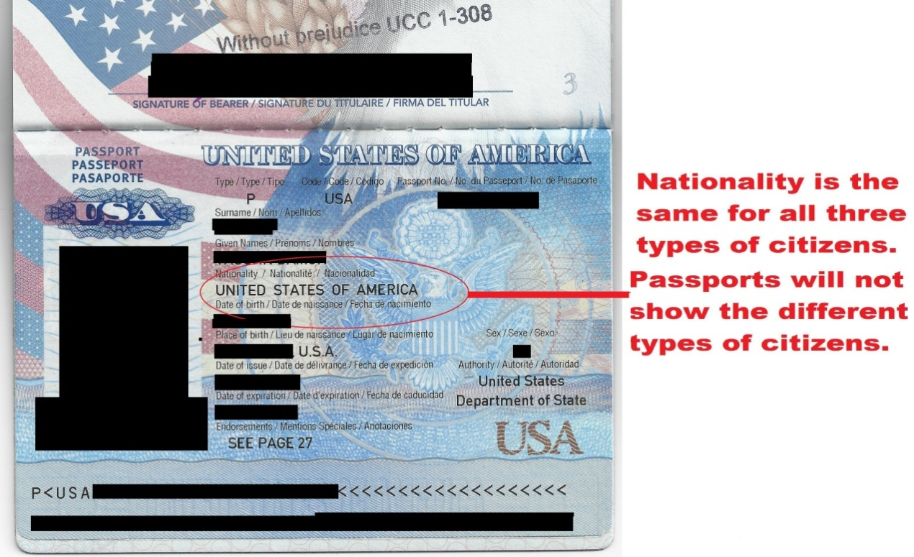

AN EXAMPLE PASSPORT FORM AND AFFIDAVIT IS INCLUDED BELOW IN THIS TREATISE.
Fill out the application in black ink as per the instructions.
The main things to remember on the Passport form, is to….

- Put in your social security number. Before, we did not put in the social security number or simply put in all zeros.
The older forms said the social security number is voluntary in the instructions of the application. It still is voluntary and a felony for them to demand it. See 42 USC 408 a-8. But if you leave it off. They may deny you the passport and keep your money. It does not matter that you give it to them. Even if they took the application, they will write your SS number on the form somewhere. So write in your social security number.

- THIS IS THE MOST IMPORTANT THING TO DO!
All of the other stuff I mention does not really matter. It’s only a way to make them pay close attention to your application. Every place that it asks if someone is a U.S. citizen; Mom, Dad or spouse or ex-spouse, you check off NO. If you check off yes to U.S. citizen on anything, then that makes you a U.S. citizen. Otherwise you are a State Citizen. NO ONE IS A U.S. CITIZEN. Not you, or your spouse, or your ex-spouse or your mom, dad or children. This is the most important step. No to U.S. citizen on everything. MAKE SURE YOU GET THIS RIGHT! This is the only thing that matters on the application!
Do not let them bully you into checking off yes to U.S. citizenship.

- Put “In care of:” with the mailing address and use the standard mailing address with zip
code. This means that this is merely where you receive your mail and you do not live in their jurisdiction. And for the permanent address, use “R.F.D.” or “Rural Free Delivery” for the address and then the city and state. Then use all zeros for the zip code. This means that you live in the Republic and not in any fictional jurisdiction.
If they force you to put something else in, then do it. It is only a way to make them pay close attention to your application. That you checked off no to all questions on U.S. citizenship.

Additional things you can do is…

- Put “without prejudice” above your signature. This insures that you are not a legal fiction
and are not contracting away your rights. Although this should not be needed as a State Citizen.
- Expedite your passport. The faster you get it, the faster you will be free. In addition, the
State Department will delay your passport to the maximum allotted time otherwise. They do not want you to have it.
- DO NOT INCLUDE AFFIDAVITS OF CITIZENSHIP WITH YOUR APPLICATION, OR UNDERLINE NON-CITIZEN NATIONAL. You will be denied.
Do not sign it until you are in front of the acceptance agent.
They are not allowed to refuse your application or make any changes. To do so is a crime. You can report the person to the U.S. Attorney General.

What if you already have a passport?
Even if you already have a passport from before or have a current passport, you can get a new passport with this method by doing another DS-11. And yes, you have to put down on the application that you had one in the past, and show the old passport with the application, or fill out a lost form. It does not matter what you put on the previous passport. You are updating your information. Sometimes the State Department will write a passport holder that they are being denied because they already have a passport. I’m not sure, but I think they have updated your information at that point, that you are a State Citizen, and your current passport most likely shows that, when the information is run.
Anyone who is denied a passport for various reasons such as back child support and ect…, are still protected. It seems their information is updated. And some folks have told me that they were made eligible about 3 or 4 months after applying and being denied because of back child support.
I have also found that so far, even if someone is out on parole, bond or probation, they can get one too without arrest, and stop further harassment. But if you fill it out wrong, they will arrest you the next day. I seen it happen. Check off “NO” to all questions on U.S. citizenship.

I personally have done all of the above for myself and others.

NOTE: It is rumored that the State Department will require proof of travel such as a VISA or other proof of travel. This is because the enemy is in panic. They do not want their slaves to escape. It’s merely a way to discourage you from getting this type of passport. And most countries do not require a VISA for Americans. So if this becomes the case, I suggest you simply make a hotel reservation for a night or two across the border in Canada or some place. Then print off a copy of the reservation for proof to include with your application. You can always cancel the reservation after you get your passport, if you change your mind or not able to go.

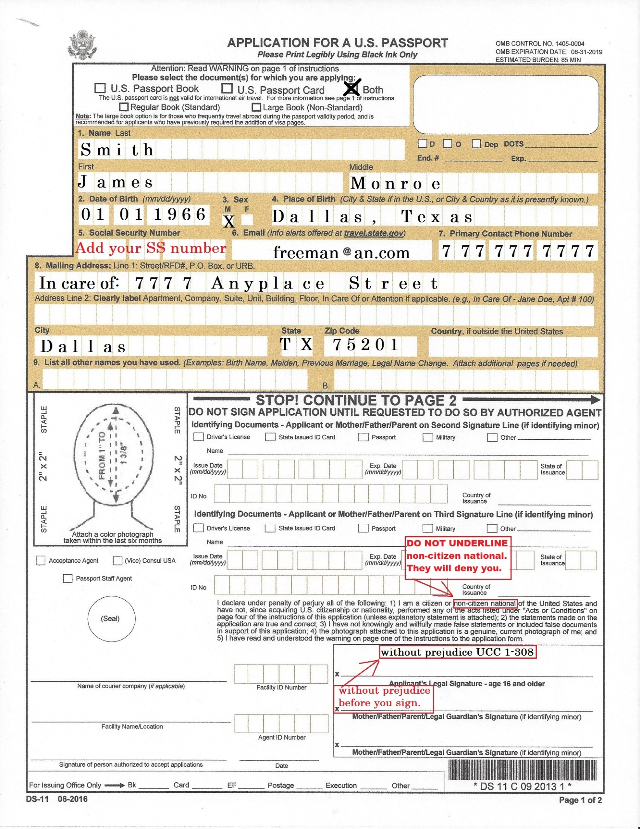
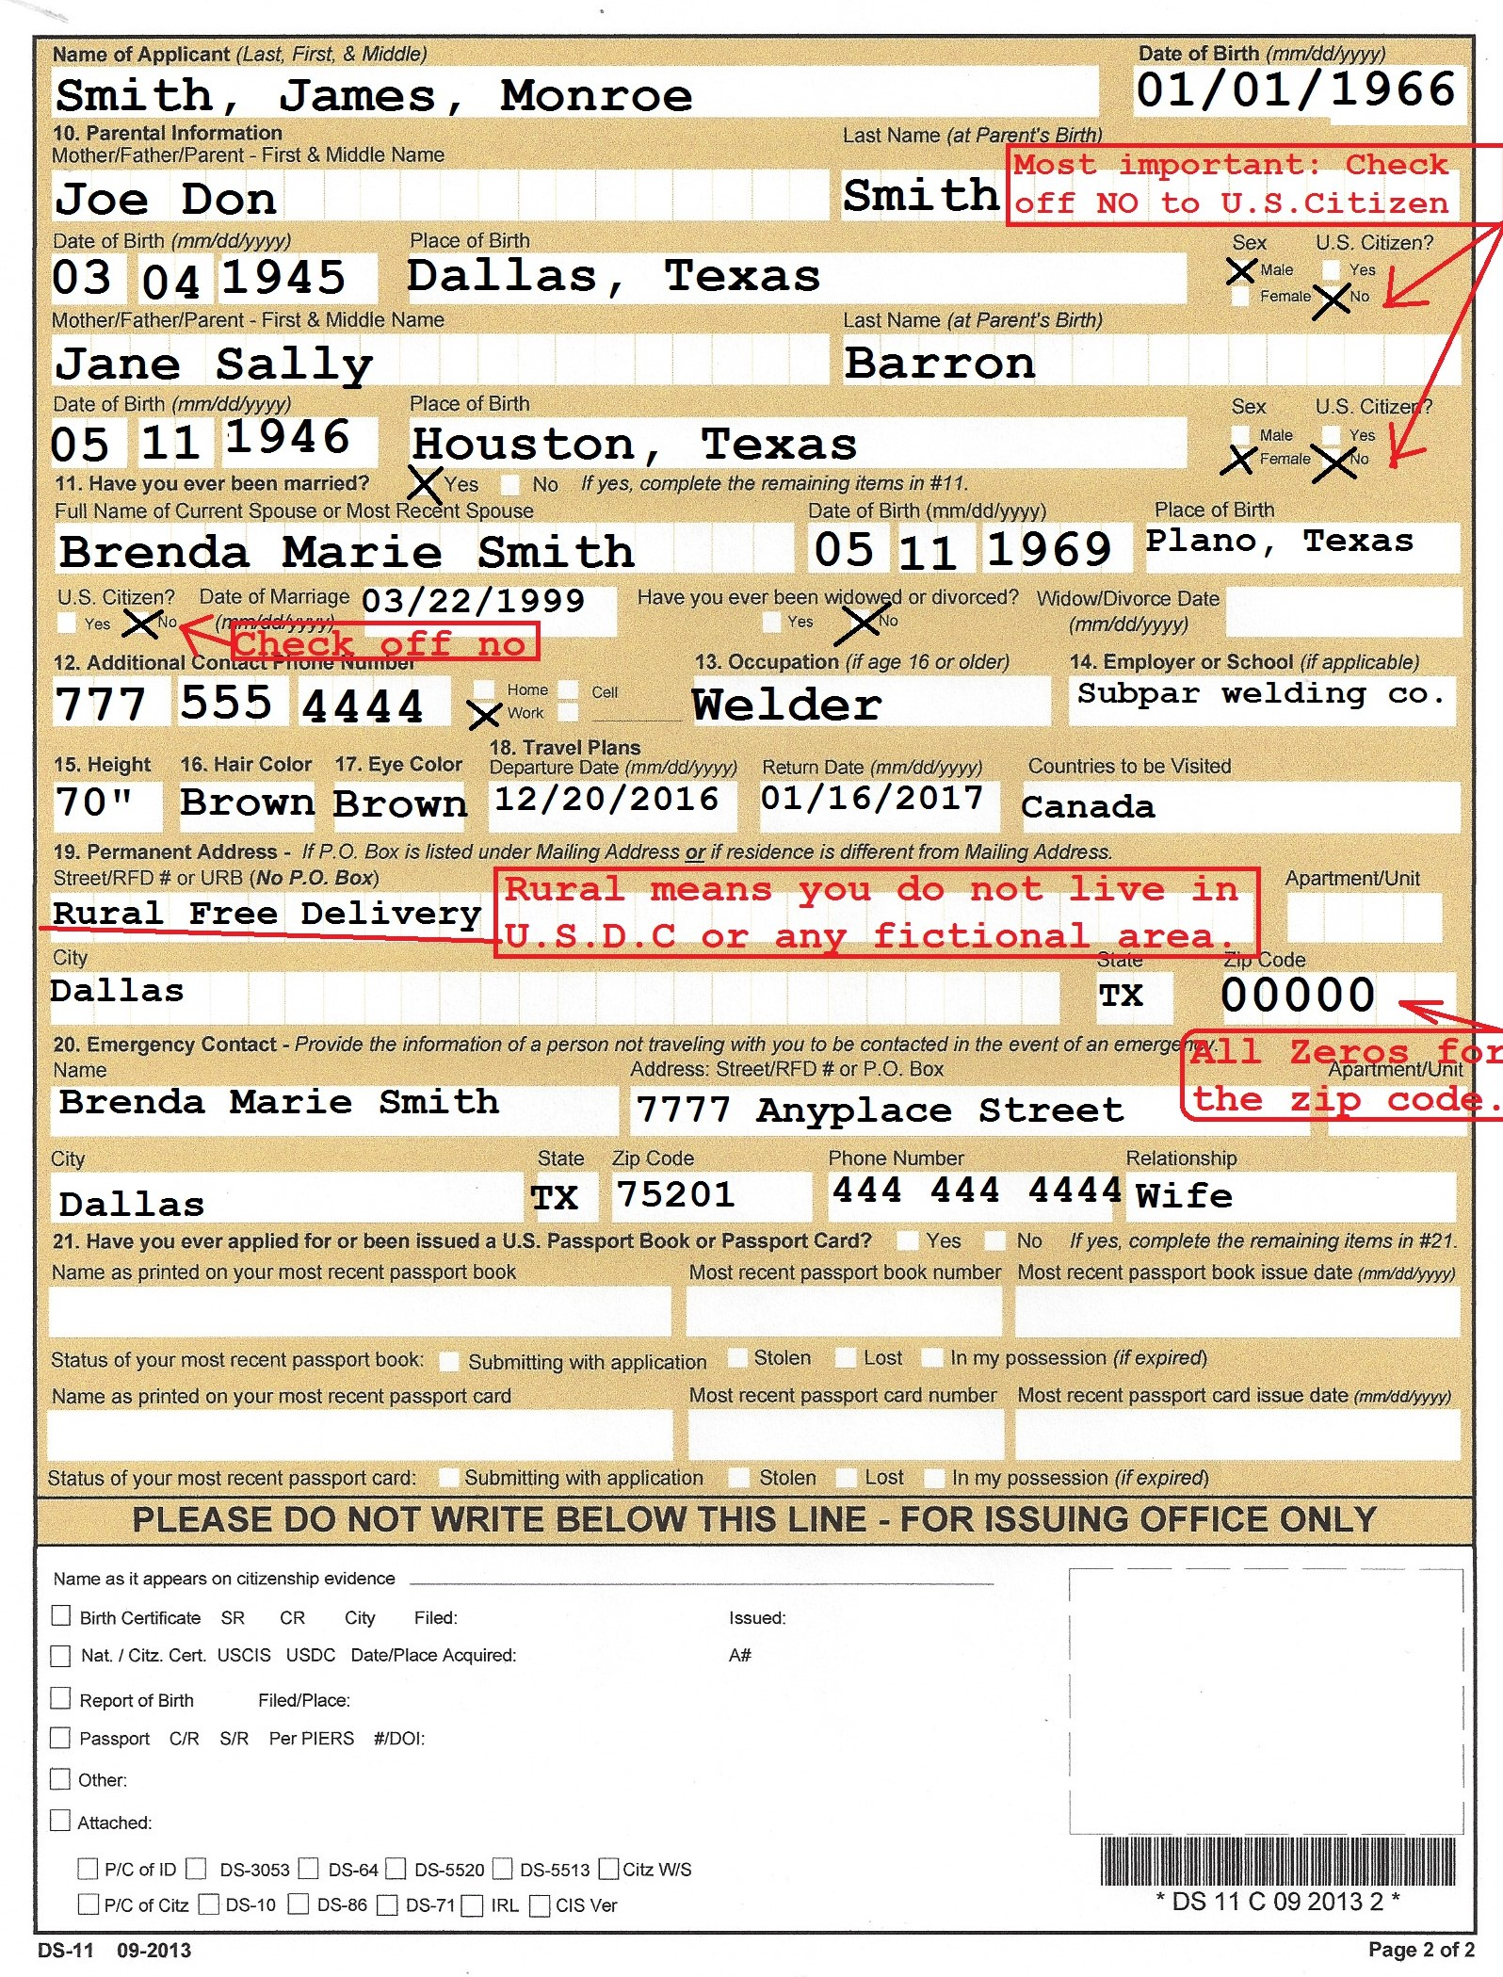

Traps to avoid.
- Do not put down that you are a U.S. citizen on anything. Usually the proper choice given is Citizen of the United States, Non-citizen national or other. They used to have places on the form to check off State Citizen but not anymore. Yes, they make it as confusing as possible.) Or the form may only have a yes or no question if you are a U.S. citizen. Check off no. Checking off no to U.S. citizenship does not prevent you from benefits or rights. If you are registered to vote, you still can vote. Because you are a asked if you are a Citizen of the Untied States.
- Your social security number is voluntary. But again, if you do not put it on the passport application or you will be denied. So it does not hurt you to use it if you need to. But it is a felony for anyone to compel your social security number from you. See… 42 USC 408 A-8. I am told that you can get a EIN number for banking purposes only. Then use that with your passport to get a bank account. Do not give them your SS number when getting an EIN number or it will be denied.
- Always put the phrase “without prejudice” with your signature. State Citizens do not have to do this. But it sure does not hurt. It means you are not giving up any rights or otherwise contracting. See UCC 1-308 which was formally UCC 1-207.
When you get a job, fill out the I–9 form. Check off “Citizen of the United States” and I know folks who have also checked off “non-citizen national” with no consequence. You can use your social security number here if you wish, but the form itself says it is voluntary. And they may old out SS but not taxes. But you do not have to. The employer has the choice of your passport for ID or both your DL and SS card. Use your passport for ID. Claiming State Citizen does not prevent you from getting any benefits from anything. Sign everything with the phrase “without prejudice”. I as well as others do not use the W-4 or w-9 form for tax withholding. We use the W-8BEN. Some employers will not except it and demand a W-4 or w-9. But it is illegal for them to demand it. But it seems most employers will and should except the W-8BEN. You do not have to file taxes. If you feel uneasy about not paying taxes, you can continue to pay them and see how your passport works for you. But you are only feeding the U.S.D.C. beast that is enslaving the country.
When you buy a gun and fill out the form, do not check off that you “have renounced your U.S. citizenship”. You never were a U.S. citizen, so there is no citizenship to renounce. I have bought plenty of guns since. And used my passport for ID rather than a State ID. Again, not everyone understands this. So some gun dealers are apprehensive. Just tell them to run the application. If anything is wrong, they will deny it. Which has never happened with anyone I know. And interestingly, many have reported buying guns outside of their state with no problem, as it should be.
Never put down you live in the United States. You live in the United States of America (U.S.A.). Or simply say you live in America. On lots of forms you will see United States, but they do not make it clear if it’s the federal corporation or the republic. I believe if it asks what country you live in, then it must be the republic, not the corporation. The corporation is not a country. You find this all through the United States Code and the Code of Federal Regulations for the purpose of confusion. So study carefully to see what they mean by, “The United States”.
Once you receive your passport, you should never have to pay income taxes, you can carry any gun, you should not get tickets. But keep your nose clean on traffic tickets. About ten of the states will try and war with you on traffic tickets to fool you into believing they still have jurisdiction. But if you fight them one time with an affidavit of treason and deprivation of rights under color of law, you may never get another one. You also do not need licenses permits and fees and the bills of exchange will work if properly served. And they cannot come after you for unsecured debt. You may get a few letters for not paying debt, but you cannot be sued for it. Simply send back any summons with a cease and desist letter as mentioned later. Or better, do not answer it. They cannot even get a default judgement. The only thing you cannot do is cause injury. They can arrest you for causing injury to someone. And anyone that causes injury needs to be arrested.
Even though you can do all these things, I highly recommend that you do not shove it in their face. Be on good behavior and do not draw attention to yourself. Also give any police officer a friendly chance to discover who you are. Hand him whatever he asks for. Most usually you will not get a ticket in most States except for about ten at this time. I’ll address that later. If you a ticket in one of the other 40 states, sign it “without prejudice” and forget it. Do not go to court. There is nothing they can lawfully do. DO NOT GO TO COURT, THERE IS NOTHING THEY CAN LAWFULLY DO. Several law enforcement officials have confirmed for me, that when they pull someone over that is Red Flag or Restricted because of the State Citizen passport, that they have no jurisdiction to arrest them or write tickets. But they are told to write the ticket anyway and let the court handle it. They have no idea what happened. Nothing did happen. DO NOT PAY THE TICKET! DO NOT GO TO COURT!
However, there are now currently ten or so States that I know of where the “Shadow Government / Deep State criminals has taken over, and sometimes will instruct the officer to give you a ticket. At this moment and time, they are Arkansas, Missouri, Colorado, Minnesota, Hawaii, Oregon, Arizona, Alabama, Texas and a couple others I cannot think of. I didn’t know what was going on at first. But we found out from a government official, that the State Department has not been putting people all the way over to State Citizen status for the past few years. Unlawful of course. But they put you over to RED FLAG status for an unknown amount of time. Then if there are no incidents, they put you over to State Citizen status. The difference is only concerning traffic tickets. Everything else such as taxes and lawsuits are still the same. Do not worry about that. Since the passport removes your SS number and name from all of the government attack systems, they cannot not come after you that way. So they attack the driver’s license itself. They suspend the license and put a warrant on the license. They will not arrest you, but will continue to pile up the fines and warrants. Then when you apply for a job, all of that stuff pops up, and you cannot get a job. Now you do not need a license any longer, and some have chosen to turn theirs in. And the passport is all they hand the cop when pulled over. I know them. See…
"The acceptance of a license, in whatever form, will not impose upon the licensee an obligation to respect or to comply with any provision of the statute or with the regulations prescribed that are repugnant to the Constitution of the United States." W. W. CARGILL CO. v. STATE OF MINNESOTA, 180 U.S. 452 (1901) 180 U.S. 452
Also see…
“Speeding, running stop signs, traveling without license plates, or registration are not threats to the public safety, and thus are not arrestable offenses.” Christy v. Elliot, 216 I 131, 74 HE 1035, LRA NS 1905-1910
Many (including me) have reported that the nine-digit number on the passport lets them buy insurance, escape sales tax, buy guns, get and International Drivers Permit and etc… I and my family at this time have car insurance using only the number under the picture on the passport card. Do not give them your SS number or it will link up your State driver’s licenses. Most people have found that by using the nine digits on the passport card, that their auto insurance is 20% to 50% cheaper. Mine is about 25% cheaper.
Not all insurance companies will do this. It seems to be about 7 out of 10. And you cannot do this online. You have to call the insurance company by phone. You cannot get insurance on your car if it is not registered. But then again, if you have the State Citizen passport and have turned your license in for a State ID, then you do not need to buy insurance. And you can call the county assessor and unregister your car or truck. Tell them you no longer have it. This take your car completely out of their jurisdiction. I would leave the plates on so that the police cars automatic license plate readers, can still read the plate, and there would be less chance of getting pulled over. Now in full disclosure, I personally have not turned in my license or unregistered any of my cars. But I am never bothered. They know I will put up a fight. And just like any criminal, they are terrified of an armed victim. I’ve taken them to task many times. And they have not bothered me in about 5 or so years. But I cannot guarantee, that you will not run into a corrupt official.
So here is how I helped a friend put the hurt on some corrupt officials in Arkansas. If you want to keep your license, and you live in one of these States that will write you a ticket, then simply show up for court with at least one witness. This will give you two witnesses including you. (The more the better) and your birth certificate. Continue to show your birth certificate and say you are a State Citizen, dismiss this case. Ask for the performance bond. This is the bond that you file a claim on for your injuries. You have been injured in that you are being deprived rights under color of law 18USC241 and 18USC242 and also here is a little jewel I just recently found… 18 U.S. Code § 1545. Safe conduct violation, “Whoever violates any safe conduct or passport duly obtained and issued under authority of the United States shall be fined under this title, imprisoned not more than 10 years, or both.”
Do not get yourself into contempt with a corrupt judge. Do not plea. Pleading perfects, the jurisdiction of the court. And do not take a plea bargain. If the judge runs over you, then you and your witness can write an affidavit of high crimes and treason committed by…(whoever the judge, cop and prosecutor are) by how ever many witnesses you have. At least two and the more the better. Make a couple of notarized copies and file one with the county. Then get about7 or 8 certified copies from the county and send the complaints to the FBI, DOJ, Secret Service, President and etc… Then do not answer any suit that comes your way. Typically, it is stupid for them to sue you if you have at least two witnesses because it now become a part of a court record, and they must be prosecuted. This ruins their government career forever, because it comes up on all background searches. It is also acts as a lis pendens lien on all of their property and assets. They will not be able sell their property or borrow money. But reserve this for have to cases. We only did this because they would not relent. I typically find the State officials will do nothing to help you. They seem to be the most corrupt. Also you can file a lis pendens lien or a flat out lein on the case number and its bonds including the performance bond. NEVER file a lien on personal property. Only the case number and its bonds, bonds of officials and their oaths of office.
You can also get a foreign driver’s license with an IDP by writing this email address. notnow9-abe@yahoo.com
Always use the passport for your ID where possible. Some places will give you a hard time while buying a gun and etc... But once they run it, they are surprised to find that they can sell you one. You can order the passport card, book or both. If money is an object, I highly recommend that you order the card, to carry in your wallet or purse. It’s cheaper. When the officer runs your ID, he/she will see your status and has to let you go, unless you live in one of the aforementioned 10 states. The status most law enforcement sees on your background check is similar to the following.
RESTRICTED
DO NOT STOP, DO NOT DETAIN, DO NOT INTERROGATE.
LIFE TIME CONCEALED WEAPONS PERMIT.
The latter is to mislead the officer on why you may have a gun on you. You have your second amendment rights back. I always try to educate the officer on citizenship. But their overseers mislead them from the truth. No police officer or other official will confirm that you are on the Red Flag or Restricted List. I don't care if you have known the officer personally for 20 years and live next door to him, they will not confirm that there is anything different about your information. They do not confirm anything for me, and they will not for you.
Now I do not completely blame the law officers for their actions. They have been brainwashed by the truly evil people in government, elected officials, the BAR association and bankers. So it’s a little unfair to them, because they have so badly been misled. But they still have an Oath of Office, so there is no excuse for their behavior. If you are in law enforcement and reading this, I hope you will look at your Oath of Office and then the constitutions you have sworn to uphold. Dig for the answers and educate yourself. I have a great respect for peace officers that actually protects the people and puts their lives on the line for others. But I have no such feeling for those who violate their Oath of Office. Or cause trouble for people, when there is not injured party as required by the Common Law. See…
"For a crime to exist, there must be an injured party. There can be no sanction or penalty imposed upon one because of this exercise of Constitutional rights."- Sherar v. Cullen, 481 F. 945.
I have received a passport using this method. And so have many others using this method. I don’t pay income taxes, I do not get tickets, I do not have to register things or get permits or licenses, and I am left alone for the most part. (I do get a fishing license from Arkansas because I like the work they do with the money. And it’s cheap. And I got it with my passport, not a state ID. But I never sign it.) So weigh your options. Some folks get rid of their driver’s licenses and deregister their cars. But some employers require one. Uber for example. I do not suggest any of this one way or the other. Decide for yourself to what extent you want to go and how much you want a fight.
I have found this to be the silver bullet. It is the difference between night and day. Some foreclosures are stopped cold because they cannot collect debt against a State Citizen valued in anything other than gold and silver coin. But if you are in a non-judicial foreclosure state, it could be a different story. See USA constitution Article 1 section 10. Federal Reserve Notes are not gold and silver coin. Prison sentences for those out on bond have gone away, real estate taxes have disappeared, and I can go on and on. But experiences do differ throughout America. Sometimes warrants go away. Sometimes they do not. But they are supposed to. Anything you have in controversy before you get the State Citizen passport may persist afterward. If it does, and you can, settle it. Then you are free and clear.
See how the passport works for you on small things before you go to bigger things.
This treatise is not to be taken as legal advice, and I do not accept any liability for what you do with the information. Please do not share this treatise with those of questionable morals.

About Taxes

Article one section ten of the USA 1789/1791 constitution prohibits States from using anything but actual gold and silver coin as tender and payment of debt. So how do they tax you in Federal Reserve notes? Federal Reserve notes are defined as obligations in 18 USC 8. And 31 USC 3124 prohibits states from taxing federal obligations except for corporations. So if a US citizen or resident alien can be taxed in Federal Reserve notes, then they are a United States corporation/ U.S. citizen. A State Citizen is not, and no unconstitutional tax can be levied against a State Citizen. And congress has not authority over State Citizens. Since many across this nation has figured out the citizenship fraud, and are correcting the fraud via passport, the enemy is in panic. The IRS has the right to inquire about taxes if you cannot prove State Citizenship. See…"Unless the defendant can prove he is not a citizen of the United States, the IRS has the right to inquire and determine a tax liability." U.S. v. Slater, 545 Fed. Supp. 179,182 (1982).

So order lots of certified copies of your birth certificate. Then make sure that you include a certified copy with any correspondence with government. If you receive letters from any government entity, mail them the birth certificate with a letter telling them to cease and desist. (An example cease and desist is at the end of this treatise.) Do this for each and every letter they send you. Always mail it back to the address you got it from, as well as to the address they want you to answer. They may send you a letter form a different address later. That’s how they try and get around it. I have mailed about 7 letters before they stopped. Some of the envelopes I didn’t even open. Do not let them scare you. Then they are finished. This goes for any government entity. (An example cease and desist is at the end of this treatise.)
Do not panic should you receive scare letters certified mail or not. They are meant to scare you into capitulation. They are meaningless, but they look like they have official jurisdiction and sites lots of law and etc… They most typically use words such as offer, request, proposal, notice of non filing, you need to, we want you to, we need you to, possible prosecution, (note the word possible) and etc… And the enemy sometimes stuffs your mailbox full of these official looking scare letters, to enhance the scare factor. (4 or 5 at a time.) And send them often. They are trying scare you into obedience. These letters are carefully crafted to leave you shaking with fear. The people who receive them, send back a cease and desist letter with birth certificate. (An example cease and desist is at the end of this treatise.)
This should be your reply with a birth certificate to each and every letter you receive from any source on any subject. Should you receive follow up letters, simply send the same thing each and every time. And include a birth certificate because it is proof of your State Citizenship. A lot of folks do not even open the letter. They simply send it back with the cease and desist and a birth certificate. Most people have reported receiving 5 to 10 letters before they stop writing. They cannot do anything. So do not worry.
I personally received a letter that said I had “10 days to comply with their request”. I laughed out loud, and threw it in the trash. Complying with a request, proposal, notice of non-filing, offer of settlement or anything with such wording is not mandatory. And had they used words like demand, amount due, tax court, I answer with a cease and desist letter with a copy of my passport and birth certificate and do not let them scare you with any threat. There is nothing they can do to you! Government officials are not even allowed on your land. Your land is allodial.
DO NOT LET THEM SCARE YOU INTO COMPLIANCE.
Fear is their only tool.

Bank Accounts and Financial Institutions ID
Banks and other financial institutions are required to have a customer identification program. Most usually they want your Social Security number and other forms of ID. However, this does not apply to a State Citizen, and they use the term “non-U.S. person” rather than State Citizen. A “non-U.S. person” / (State Citizen) only has to show their passport. See…
31 CFR 1020.220 - Customer identification programs for banks, savings associations, credit unions, and certain non-Federally regulated banks.(A) (4) (ii) For a non-U.S. person, one or more of the following: A taxpayer identification number; passport number and country of issuance; alien identification card number; or number and country of issuance of any other government-issued document evidencing nationality or residence and bearing a photograph or similar safeguard.
However, you will find the bank employees will be confused and not have a clue about this. So take in a copy of this law with you including 31 CFR 1020.220 (A) (40) ii and 42USC 408 A-8 showing that is a felony to ask for your social security number. Point out that the passport merely says you are a national and not a U.S. citizen. If you are not successful, it really doesn’t matter to use your SS number because you are a State Citizen. But the bank and/or their employees are committing a felony. See 42USC 408, A-8. You may want to make a complaint to the federal prosecutor or other agencies that have jurisdiction. But you can also apply for a EIN number for banking purposes only. Do not give the SS number or you will not get it. Then use that number in lieu of the SS number.
Law Suits
Once you have the State Citizen passport, DO NOT ANSWER A LAW SUIT. They cannot even get default judgment against you. If you answer it, then you may get hurt. I have not heard of one successful lawsuit against a State Citizen. And most did not answer. If anyone calls you about anything legal, simply say I cannot determine who you are over the phone. THEN HANG UP!
State citizenship case law
U.S. v. Anthony 24 Fed. 829 (1873) "The term resident and citizen of the United States (this means a 14th amendment citizen) is distinguished from a Citizen of one of the several states, in that the former is a special class of citizen created by Congress."
“We have in our political system a government of the United States and a government of each of the several States. Each one of these governments is distinct from the others, and each has citizens of it’s own...”
United States v. Cruikshank, 92 U.S. 542 (1875)
“...he was not a citizen of the United States, (again 14th amendment citizen) he was a citizen and voter of the State,...” “One may be a citizen of a State an yet not a citizen of the United States”.
McDonel v. The State, 90 Ind. 320 (1883)
“That there is a citizenship of the United States (again a 14th amendment citizen) and citizenship of a state,...”
Tashiro v. Jordan, 201 Cal. 236 (1927)
"A citizen of the United States is a citizen 14th amendment citizen) of the federal government ..."
Kitchens v. Steele, 112 F.Supp 383

"Taxpayers are not [de jure] State Citizens." Belmont v. Town of Gulfport, 122 So. 10.

State v. Manuel, 20 NC 122: "the term 'citizen' in the United States, (means United States citizen or legal fiction) is analogous to the term `subject' in common law; the change of phrase has resulted from the change in government."

Supreme Court: Jones v. Temmer, 89 F. Supp 1226:
"The privileges and immunities clause of the 14th Amendment protects very few rights because it neither incorporates the Bill of Rights, nor protects all rights of individual citizens. Instead this provision protects only those rights peculiar to being a citizen of the federal government; it does not protect those rights which relate to state citizenship."
Supreme Court: US vs. Valentine 288 F. Supp. 957:
"The only absolute and unqualified right of a United States citizen is to residence within the territorial boundaries of the United States." (This is the legal fiction citizen of the federal corporation)

The Amendment (14th) recognized that "an individual can be a Citizen of one of the several states without being a citizen of the United States," (U.S. v. Anthony, 24 Fed. Cas. 829, 830), or, "a citizen of the United States without being a Citizen of a state." (Slaughter-House Cases, supra; cf. U.S. v. Cruikshank, 92 US 542, 549 (1875)). (Again talking about a 14th amendment citizen)
A more recent case is Crosse v. Bd. of Supervisors, 221 A.2d 431 (1966) which says: "Both before and after the Fourteenth Amendment to the federal Constitution, it has not been necessary for a person to be a citizen of the United States in order to be a citizen of his state." Citing U.S. v. Cruikshank, supra.(confusing, but recognizes State citizenship)
The courts presume you to be a federal citizen, without even telling you that there are different classes of citizens. It is up to you dispute this. Use your passport and the actual birth certificate. See…
"Unless the defendant can prove he is not a citizen of the United States, the IRS has the right to inquire and determine a tax liability." U.S. v. Slater, 545 Fed. Supp. 179,182 (1982). (This one is misusing the term citizen of the United States for the purpose of confusion. It is a little tongue in cheek to say, a citizen who is a United States citizen)

"There are, then, under our republican form of government, two classes of citizens, one of the United States and one of the state". (Again making a distinction between a 14th amendment citizen and a State Citizen)
Gardina v. Board of Registrars of Jefferson County, 160 Ala. 155; 48 So. 788 (1909)

"The governments of the United States and of each state of the several states are distinct from one another. The rights of a citizen under one may be quite different from those which he has under the other".
Colgate v. Harvey, 296 U.S. 404; 56 S.Ct. 252 (1935)

"...rights of national citizenship as distinct from the fundamental or natural rights inherent in state citizenship".
Madden v. Kentucky, 309 U.S. 83: 84 L.Ed. 590 (1940)

"There is a difference between privileges and immunities belonging to the citizens of the United States (14th amendment citizen) as such, and those belonging to the citizens of each state as such".
Ruhstrat v. People, 57 N.E. 41 (1900)

"Therefore, the U.S. citizens (citizen of the federal corporation) residing in one of the states of the union, are classified as property and franchises of the federal government as an "individual entity"", Wheeling Steel Corp. v. Fox, 298 U.S. 193, 80 L.Ed. 1143, 56 S.Ct. 773
"...the first eight amendments have uniformly been held not to be protected from state action by the privilege and immunities clause [of the 14th Amendment]."
Hague v. CIO, 307 US 496, 520
"The right to trial by jury in civil cases, guaranteed by the 7th Amendment…and the right to bear arms guaranteed by the 2nd Amendment…have been distinctly held not to be privileges and immunities of citizens of the United States guaranteed by the 14th Amendment…and in effect the same decision was made in respect of the guarantee against prosecution, except by indictment of a grand jury, contained in the 5th Amendment…and in respect of the right to be confronted with witnesses, contained in the 6th Amendment…it was held that the indictment, made indispensable by the 5th Amendment, and trial by jury guaranteed by the 6th Amendment, were not privileges and immunities of citizens of the United States, as those words were used in the 14th Amendment. We conclude, therefore, that the exemption from compulsory self-incrimination is not a privilege or immunity of National citizenship guaranteed by this clause of the 14th Amendment."
Twining v. New Jersey, 211 US 78, 98-99
"The acceptance of a license, in whatever form, will not impose upon the licensee an obligation to respect or to comply with any provision of the statute or with the regulations prescribed that are repugnant to the Constitution of the United States." W. W. CARGILL CO. v. STATE OF MINNESOTA, 180 U.S. 452 (1901) 180 U.S. 452
“A “US Citizen” (citizen of the federal corporation) upon leaving the District of Columbia becomes involved in “interstate commerce”, as a “resident” does not have the common-law right to travel, of a Citizen of one of the several states.” Hendrick v. Maryland S.C. Reporter’s Rd. 610-625. (1914)

State Citizenship Test

The following are some of the citizenship questions you will see on various government forms styled in a way to deceive you out of your rights secured by the original constitution of our republic. United States of America and the original State constitutions. They have stopped using the term State Citizens on all of the forms for the purpose of constructive fraud. Remember that a State Citizen is a not a national of the United States. But is a national of the United States of America. See…8 USC § 1101(a) (21) The term “national” means a person owing permanent allegiance to a state. (This is a State Citizen)
(22) The term “national of the United States” means (A) a citizen of the United States, or (B) a person who, though not a citizen of the United States, owes permanent allegiance to the United States.
(23) The term “naturalization” means the conferring of nationality of a state upon a person after birth, by any means whatsoever.

Answers at the end.
Which answer should a State Citizen choose?
- Social Security form SS 5 application.
It is most important to be familiar with this form. This is the form that automatically removes you citizenship and rights. On this form are the following choices. Which answer should a State Citizen choose?
- U S Citizen
- Legal alien allowed to work
- Legal alien not allowed to work
- Other

- On employee Eligibility Verification Form I-9 form. Which answer should a State Citizen choose?
- A citizen of the United States
- A noncitizen national of the United States
- A lawful permanent resident
- An alien authorized to work

- Questionnaire for National Security Positions. Form 86. Which answer should a State Citizen choose?
- I am a U.S. citizen or national by birth, or U.S. territory/commonwealth.
- I am a U.S. citizen or national by birth born to U.S. parent(s) in a foreign county.
- I am a naturalized U.S. citizen.
- I am not a U.S. citizen.

- If you receive a CP 59 form or other letter from the IRS, You will tell them that you are a State Citizen and to cease and desist. Be sure to include a copy of your birth certificate and passport. If you receive the CP 59 form to complete, which answer should a State Citizen choose?
Explain why you do not have to file a tax return. (From 2013 CP 59 form)
My filing status was:
- Head of Household
- Married filing jointly
- Married filing separately
The following applied to me:
- I was 65 or older
- I am blind
- My spouse was 65 or older
- My spouse is blind
- I am not a U.S. citizen or permanent resident
- My work was performed in another county
- I could be claimed as a dependent on someone else’s tax return

Answers
A. There is no choice for State Citizen, so the correct answer is 4. Other. The form goes on to explain that you need paper work from the State as to why you need a social security number. Your birth certificate is the paper work. As usual, your birth certificate is proof of your citizenship and should always be included with any answer or application.
B. 1. Again no State Citizen choice, but a Citizen of the United States is a State Citizen. But many has also checked off non-citizen national (2) with no problem.
C. Again, the Questionnaire for National Security Positions. Form 86 is an attempt to confuse. They combine U.S Citizen of the corporation with a national of the USA republic. A State Citizen is a national by birth. So the answer is 1. I am a U.S. citizen or national by birth, or U.S. territory/commonwealth.
- If you receive a CP 59 form or other letter from the IRS, then you send it back with your actual birth certificate (not a photo copy). You tell them you are a State Citizen and to cease and desist. If you receive the CP 59 form, the correct answer is 8. I am not a U.S. citizen or permanent resident. A State Citizen is not a U.S. citizen or a resident of the United States the Federal corporation. A State Citizen is an inhabitant in the State in which they live. The Federal area is a fictional area, not physical.
An example Cease and Desist letter is below.
This information is also posted at coppermoonshinestills.com on the page “Beat the law”.

Below is an example Cease and Desist Letter
CEASE AND DESISIT
Nemo me impune lacessit.
PRIVATE  THIS IS NOT A PUBLIC COMMUNICATION  Notice to agent is Notice to principle  Notice to principle is Notice to Agent  Applications to all successors and assigns | From: Your Name Here  Care of postal service address:  Your mailing address  City, State union state  USA without USDC  Zip exempt, but near Your zip here
TO:
To: IRS Headquarters  Attn: To all it may concern  1111 Constitution Ave. NW  Washington DC 20224 | To: U.S. Department of the Treasury  Attn: To all it may concern  1500 Pennsylvania Ave NW,  Washington, DC 20220
Attachments:
- Birth certificate.
It is a fact that: I, Your Name Here, am a natural born State Citizen of State you were born in here, in its constitutional capacity, as one of the several states of the Union. And I am an inhabitant thereof.
It is a fact that: That my birth certificate is proof that I am a State Citizens of State you were born in here. See attached birth certificate.
It is a fact that: That my State Citizenship of Arkansas has been certified by the U.S. Department of State. See attached copy of passport.
It is a fact that: That I am not a United States citizen, resident, person, individual or any other legal fiction, nor have I ever been.
It is a fact that: I explicitly reserve all of my rights always and forevermore.
It is a fact that: That the United States, with intent and great deception, uses the term “United States citizen”, to deprive the people of their rights, their birth rights, their property and freedom. And further, to relegate the status of the people, to that of livestock.

I owe you nothing nor do you have any jurisdiction over me. Your constant unceasing letters from you and your satellite departments that harass, threatens, attempts at coercion, scare tactics, stalking and all other actions are depriving me of our right to tranquility guaranteed by the preamble of, and the rest of the constitution for the United States of America. You are violating the RICO laws, stocking laws, depriving rights under color of law as well as the common law and the constitution. Your actions are also acts of treason and tyranny.
I ORDER YOU TO CEASE AND DESIST ALL ACTIVITIES AGAINST ME!
You Name Here
Twenty seventh day of May 27th in the year of our Lord 2016
By: ______________________________________________

